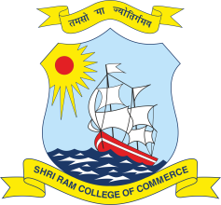 | SHRI RAM COLLEGE OF COMMERCE  University of Delhi, Maurice Nagar, Delhi – 110 007  Website: www.srcc.edu Phone: 27667905, 27666519
June 24, 2020

NOTICE
Regarding Downloading of Admit Cards
for July 2020 Open Book Examinations (OBE)

Detailed instructions regarding downloading of Admit Cards for the forthcoming July 2020 OBE has been sent to the registered email IDs/address of the Semester VI students. The concerned students are advised to check the Inbox/Spam of their respective email IDs/address.

In case of any query/concern/discrepancy related to Admit Card please contact at the following email IDs/address by 30.06.2020.

B.A. (Hons.) Economics : seema@srcc.du.ac.in
B.Com. (Hons.) : kavinder.singh@srcc.du.ac.in

PRINCIPAL

